**Final Year B. Tech. (CSE) – I : 2021-22**

**4CS462 : PE2 - Data Mining Lab**

**Assignment No. 3**

**Group id: DM21G12**

**Group members:**

**Abhishek More(2018BTECS00037)**

**Sushil Wagh(2018BTECS00031)**

**Title :** Use/extend the data analysis tool (GUI) developed in Assignment No. 2

**Objective/Aim :**

perform the following pre-processing task :

1. Correlation analysis - Chi-Square Test

a. User should be able to choose any two attributes.

b. Display the contingency table

c. Show the chi-square value and conclusion whether the selected attributes are

correlated or not.

2. Correlation analysis – Correlation coefficient (Pearson coefficient) & Covariance

a) User should be able to choose any two attributes.

b) Show the calculated values and conclusion whether the selected attributes

are correlated or not.

3. Normalization using following techniques :

a. Min-max normalization

b. Z-Score normalization

c. Normalization by decimal scaling

**Introduction:**

Correlation Analysis is statistical method that is used to discover if there is a relationship between two variables/datasets, and how strong that relationship may be.

In terms of market research this means that, correlation analysis is used to analyse quantitative data gathered from research methods such as surveys and polls, to identify whether there is any significant connections, patterns, or trends between the two.

Essentially, correlation analysis is used for spotting patterns within datasets. A positive correlation result means that both variables increase in relation to each other, while a negative correlation means that as one variable decreases, the other increases.

**Theory/Algorithms:**

**1. Correlation analysis - Chi-Square Test**

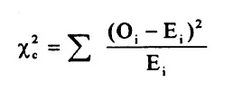

The subscript “c” is the degrees of freedom. “O” is your observed value and E is your expected value. It’s very rare that you’ll want to actually use this formula to find a critical chi-square value by hand. The summation symbol means that you’ll have to perform a calculation for every single data item in your data set. As you can probably imagine, the calculations can get very, very, lengthy and tedious.

There are a few variations on the chi-square statistic. Which one you use depends upon how you collected the data and which hypothesis is being tested. However, all of the variations use the same idea, which is that you are comparing your expected values with the values you actually collect. One of the most common forms can be used for contingency tables:

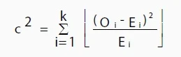

Where O is the observed value, E is the expected value and “i” is the “ith” position in the contingency table.

A low value for chi-square means there is a high correlation between your two sets of data. In theory, if your observed and expected values were equal (“no difference”) then chi-square would be zero — an event that is unlikely to happen in real life. Deciding whether a chi-square test statistic is large enough to indicate a statistically significant difference isn’t as easy it seems.

**2. What Is the Correlation Coefficient?**

The correlation coefficient is a statistical measure of the strength of the relationship between the relative movements of two variables. The values range between -1.0 and 1.0. A calculated number greater than 1.0 or less than -1.0 means that there was an error in the correlation measurement. A correlation of -1.0 shows a perfect negative correlation, while a correlation of 1.0 shows a perfect positive correlation. A correlation of 0.0 shows no linear relationship between the movement of the two variables.

Correlation statistics can be used in finance and investing. For example, a correlation coefficient could be calculated to determine the level of correlation between the price of crude oil and the stock price of an oil-producing company, such as Exxon Mobil Corporation. Since oil companies earn greater profits as oil prices rise, the correlation between the two variables is highly positive.

**2.1 Understanding the Correlation Coefficient :**

There are several types of correlation coefficients, but the one that is most common is the Pearson correlation (r). This measures the strength and direction of the linear relationship between two variables. It cannot capture nonlinear relationships between two variables and cannot differentiate between dependent and independent variables.

A value of exactly 1.0 means there is a perfect positive relationship between the two variables. For a positive increase in one variable, there is also a positive increase in the second variable. A value of -1.0 means there is a perfect negative relationship between the two variables. This shows that the variables move in opposite directions—for a positive increase in one variable, there is a decrease in the second variable. If the correlation between two variables is 0, there is no linear relationship between them.

The strength of the relationship varies in degree based on the value of the correlation coefficient. For example, a value of 0.2 shows there is a positive correlation between two variables, but it is weak and likely unimportant. Analysts in some fields of study do not consider correlations important until the value surpasses at least 0.8. However, a correlation coefficient with an absolute value of 0.9 or greater would represent a very strong relationship.

**2.2 KEY TAKEAWAYS :**

* Correlation coefficients are used to measure the strength of the relationship between two variables.
* Pearson correlation is the one most commonly used in statistics. This measures the strength and direction of a linear relationship between two variables.
* Values always range between -1 (strong negative relationship) and +1 (strong positive relationship). Values at or close to zero imply a weak or no linear relationship.
* Correlation coefficient values less than +0.8 or greater than -0.8 are not considered significant.

**3. Normalization :**

Normalization is used to scale the data of an attribute so that it falls in a smaller range, such as -1.0 to 1.0 or 0.0 to 1.0. It is generally useful for classification algorithms.

**3.1 Need of Normalization –**

Normalization is generally required when we are dealing with attributes on a different scale, otherwise, it may lead to a dilution in effectiveness of an important equally important attribute(on lower scale) because of other attribute having values on larger scale.

In simple words, when multiple attributes are there but attributes have values on different scales, this may lead to poor data models while performing data mining operations. So they are normalized to bring all the attributes on the same scale.

**3.2 Methods of Data Normalization –**

1. Decimal Scaling
2. Min-Max Normalization
3. z-Score Normalization(zero-mean Normalization)

**Procedure:**

**Pearson’s correlation coefficient formula**

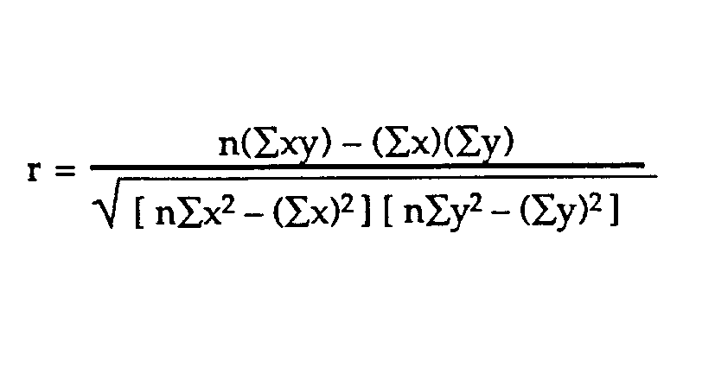

**Covariance:**

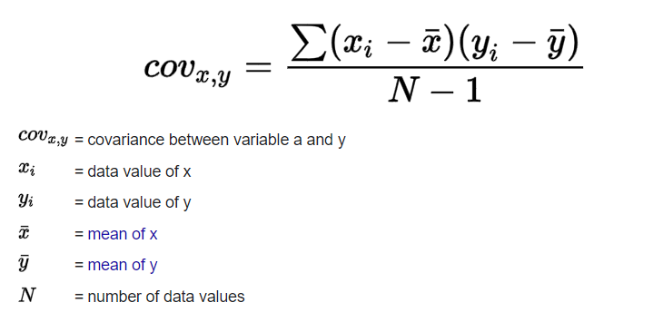

**Decimal Scaling Method For Normalization –**

It normalizes by moving the decimal point of values of the data. To normalize the data by this technique, we divide each value of the data by the maximum absolute value of data. The data value, vi, of data is normalized to vi‘ by using the formula below –

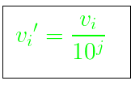

where j is the smallest integer such that max(|vi‘|)<1.

Let the input data is: -10, 201, 301, -401, 501, 601, 701

To normalize the above data,

Step 1: Maximum absolute value in given data(m): 701

Step 2: Divide the given data by 1000 (i.e j=3)

Result: The normalized data is: -0.01, 0.201, 0.301, -0.401, 0.501, 0.601, 0.701

**Min-Max Normalization –**

In this technique of data normalization, linear transformation is performed on the original data. Minimum and maximum value from data is fetched and each value is replaced according to the following formula.



Where A is the attribute data,

Min(A), Max(A) are the minimum and maximum absolute value of A respectively.

v’ is the new value of each entry in data.

v is the old value of each entry in data.

new_max(A), new_min(A) is the max and min value of the range(i.e boundary value of range required) respectively

**Z-score normalization –**

In this technique, values are normalized based on mean and standard deviation of the data A. The formula used is:

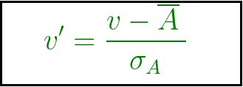

v’, v is the new and old of each entry in data respectively. σA, A is the standard deviation and mean of A respectively.

**Result/Observations/Screenshots:**

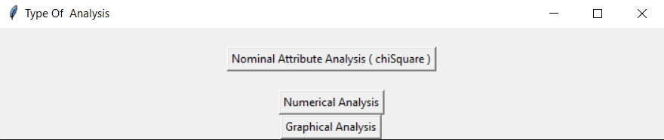

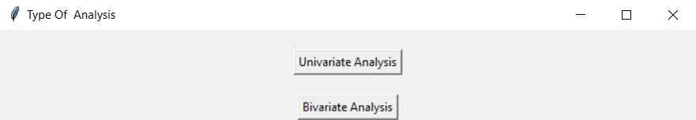

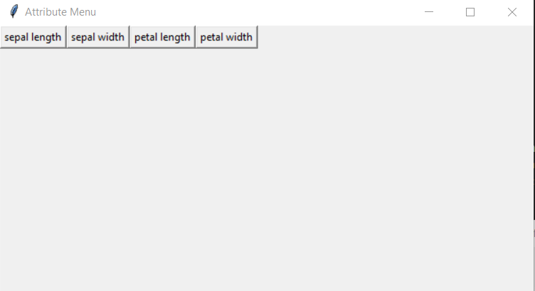

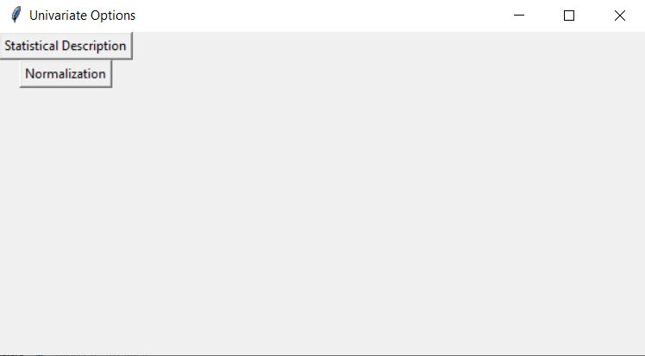

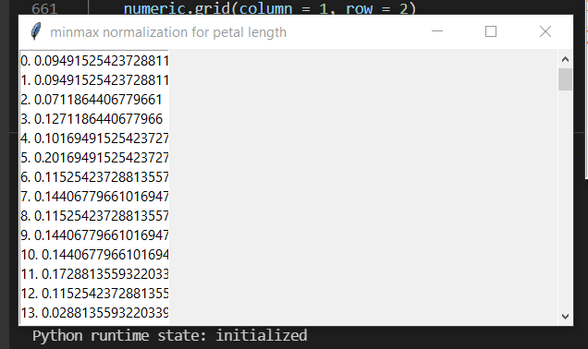

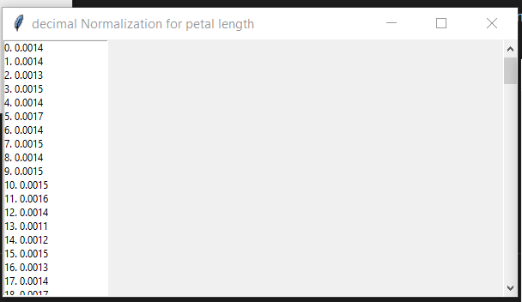

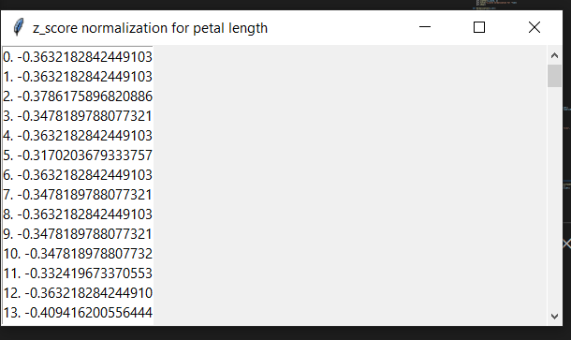

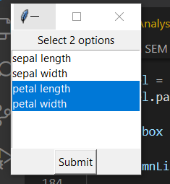

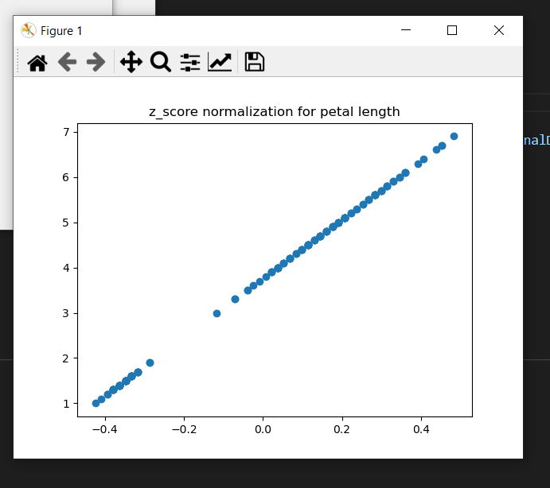

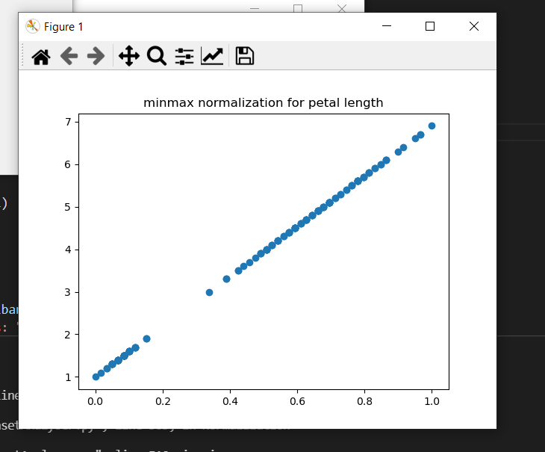

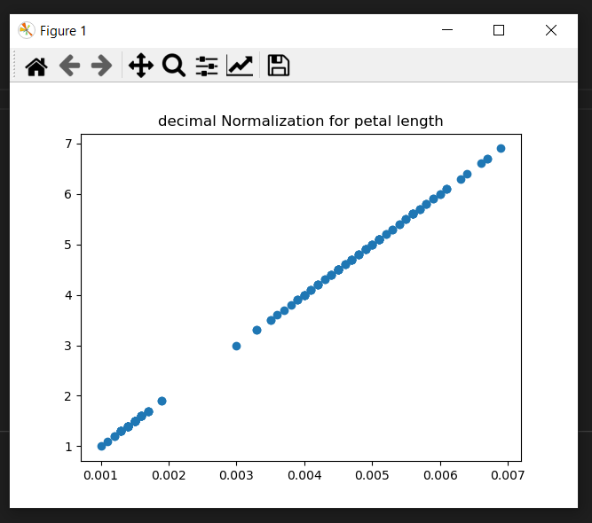

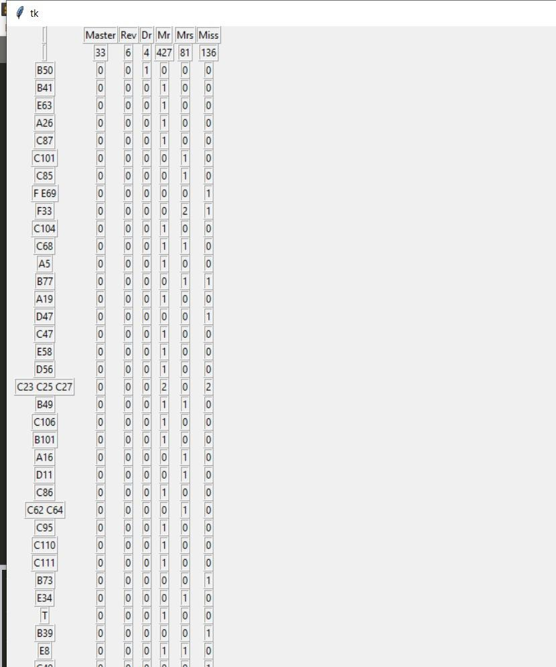

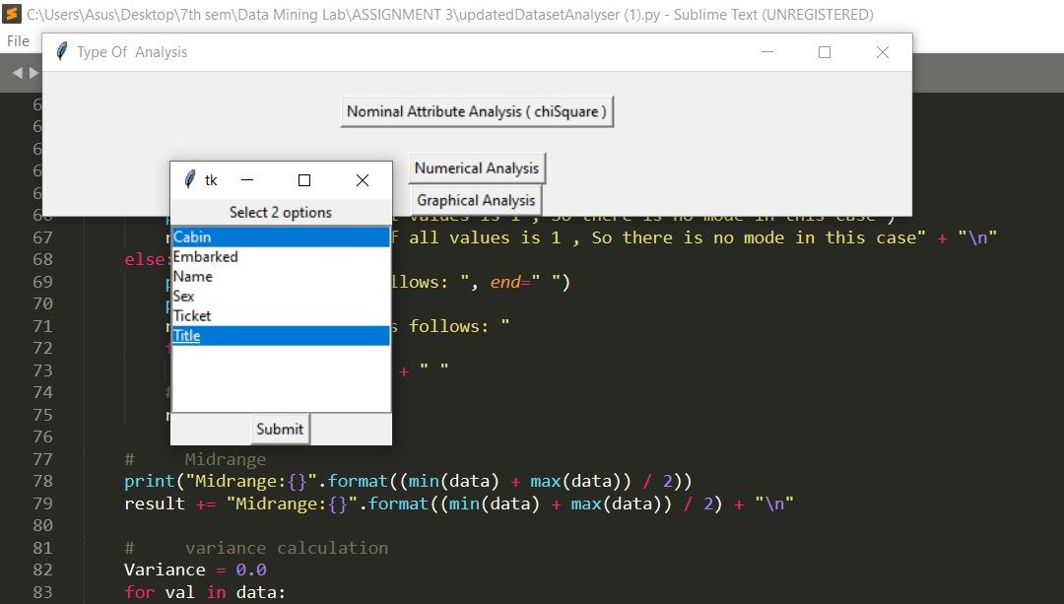

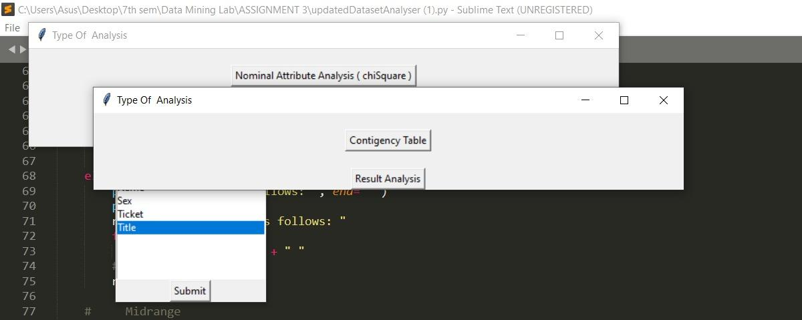

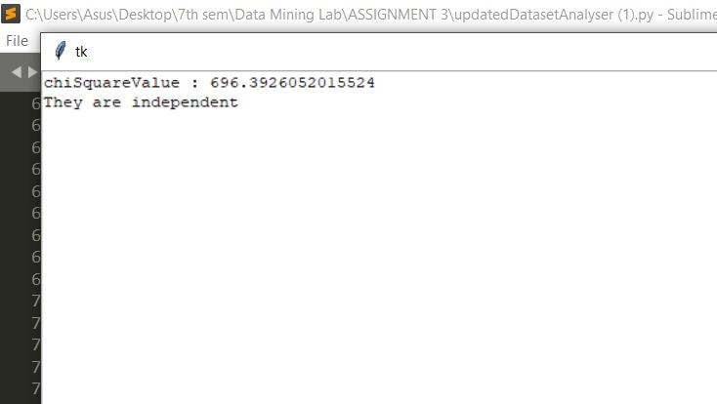

**Conclusion:**

Studied and implemented the targeted concepts

**References:**

* [Correlation Coefficient: Simple Definition, Formula, Easy Calculation Steps (statisticshowto.com)](https://www.statisticshowto.com/probability-and-statistics/correlation-coefficient-formula/#Pearson)
* <https://www.geeksforgeeks.org/data-normalization-in-data-mining/>
* [python - How to plot 1-d data at given y-value with pylab - Stack Overflow](https://stackoverflow.com/questions/7352220/how-to-plot-1-d-data-at-given-y-value-with-pylab)